Welcome to Generation Hatton!

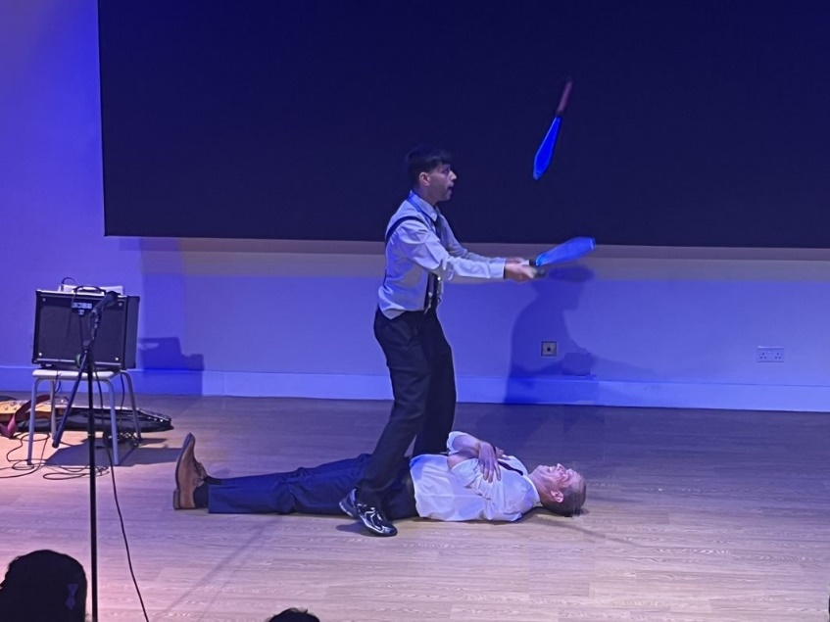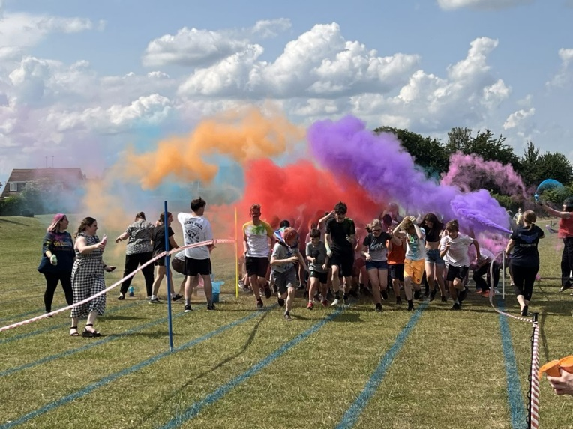

Select from our list of editions below!

We will keep you updated on all things Hatton, from events such as the yearly **colour run** to **Hatton’s Got Talent.**

We will also run **art competitions** and display all the creative and artistic endeavours of Hatton’s students.

Our team of sixth formers has worked hard to bring you the monthly **Generation** **Hatton Magazine!** On our editions page you will find articles, art submissions and quizzes for you to take part in.